Peter DeCicco
Acupuncturist

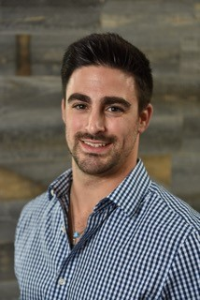

Peter DeCicco is a licensed Acupuncturist in the states of New York and New Jersey. Peter received his undergraduate degree from William Patterson University and continued his studies at The Eastern School of Acupuncture and Traditional Medicine in Montclair, New Jersey. He is trained in Traditional Chinese Medicine, Japanese Style Acupuncture and Five Element Style Acupuncture.
While completing an internship at the Eastern School, Peter studied under world renowned acupuncturist Kiiko Matsumoto, and treated a wide variety of illnesses and conditions. After completing his extensive training in Acupuncture, he began his career in Brooklyn, New York, specializing in pain management and trigger point acupuncture.
Knowing the tremendous benefits Acupuncture can offer, Peter treats his patients for chronic pain and conditions such as lower back pain, headaches, neck pain, fibromyalgia, seasonal allergies and infertility. Peter works hand in hand with his patients to guide them on their journey to optimal health.

