Dr. Stephen Jones
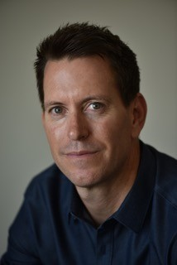
Chiropractor & Founder of Total Health Associates

Dr. Stephen Jones is the founder and owner of Total Health Associates in Waldwick, New Jersey. He is a board certified, licensed Chiropractor since 1998. While classically trained as a chiropractor, early in his career, Dr. Jones developed a true appreciation for the vast array of healing disciplines, and has incorporated Physical Therapy, Acupuncture and Massage Therapy into his practice.
After completing his Doctorate degree, Dr. Jones began his career in Woodbridge, Virginia. Dr. Jones joined a busy practice where he dedicated 9 years gaining valuable experience.
In 2007, Dr. Jones returned to his hometown of Waldwick, NJ and opened Total Health Chiropractic. Over the past eight years, Total Health Chiropractic has experienced significant growth by combining authenticity in care and dedication to the community. In June of 2014, Dr. Jones moved his practice to a larger clinic and was finally able to honor his early vision of more comprehensive patient care. Thus, Total Health Associates was born. Total Health Associates is comprised of a handpicked team of specialists: PHYSICAL THERAPISTS, ACUPUNCTURISTS, MASSAGE THERAPISTS AND CHIROPRACTORS.
Having trained staff in orthopedics, women's health, neurologic and sports related injuries, Dr. Jones is able to treat his patients with his distinct integrated wellness philosophy. Dr. Jones received his Bachelor of Science degree from Muhlenberg College in 1993 and his Doctorate of Chiropractic from Life University in Marietta, Georgia in 1998. He was awarded his license from the New Jersey State Board of Examiners in 2003 and holds license in Virginia as well. Dr. Jones has advanced certification in Torque Release Technique and Graston Soft Tissue treatment. He was awarded Family Chiropractor of the year in 2008 and 2009 and is a member of the Waldwick Chamber of Commerce and the Association of New Jersey Chiropractic.
He is an avid outdoorsman and exercise enthusiast. He is a father of two daughters and lives locally in Bergen County.

